RestOn IOS SDK Reference
V1.0
Author: XIAOSAN LIU
2017/07/10

Change log
Date | Log | Author
2023-12-12 | Create | XIAOSAN LIU

Internal document. Do not pass away

TOC

Change log 1
TOC 2
IOS SDK Intro 6
1. Function and Purpose 6
Functions 6
Integration 6
1 . framework 6
2 .Integration 7
API 8
How to call method 8
1. Scan Bluetooth 8
Description 8
Parameters 8
2. Stop Scan 9
Description 9
Parameters 9
3. Connnect Device 9
Description 9
Parameters 9
4. Get device info 10
Description 10
Parameters 10
5. SDC100 control function 10
Description 10
Parameters 10
6. Under bed light switch 11
Description 11
Parameters 11
7. SDC100 params config init 12
Description 12
Parameters 12
8. Get SDC100 config info 12
Description 12
Parameters 12
9. Get SDC100 work mode 13
Description 13
Parameters 13
10. Snore meddle switch 13
Description 13
Parameters 13
11. Get Snore meddle config 14
Description 14
Parameters 14
12. Subscribe snore status 14
Description 14
Parameters 14
13. Get snoring status 15
Description 15
Parameters 15
14. SDC100 clock 15
Description 15
Parameters 15
15. Get SDC100 clock list 16
Description 16
Parameters 16
16. Clock global config 17
Description 17
Parameters 17
17. Get SDC100 clock global config 17
Description 17
Parameters 17
18.SDC100 good night mode to set 18
Description 18
Parameters 18
19.Get SDC100 good night mode 18
Description 18
Parameters 18
20.SDC100 leftbed mode to set 19
Description 19
Parameters 19
21.Get SDC100 leftbed mode 19
Description 19
Parameters 19
22.SDC100 leftbed night light to set 20
Description 20
Parameters 20
23.Get SDC100 leftbed night light 20
Description 21
Parameters 21
24.SDC100 Snoring meddle to test 21
Description 21
Parameters 21
Object definition 21
SLPTransforCallback 21
Description 21
Method 22
Parameters 22
SLPDataTransferStatus 22
SLPPeripheralInfo 23
Description 23
Fields 23
SDCDeviceInfo 23
Descrption 23
Fields 23
SDCBedConfig 23
Description 23
Fields 23
SDCWorkMode 24
Description 24
Fields 24
SDCSnoreMeddle 25
Description 25
Fields 25
SDCSnoreStatus 25
Description 25
Fields 25
SDCClockInfo 25
Description 25
Fields 25
SDCGlobalClock 26
Description 26
Fields 27
SDCGoodNightMode 27
Description 27
Fields 27
SDCLeftbedMode 27
Description 27
Fields 27
SDCNightLight 28
Description 28
Fields 28
Notification 28
Description 28
Fields 28

IOS SDK Intro

Function and Purpose
SDC100 ble SDK,launched by Sleepace, is a software development kit for fast Internet APP development on iOS platform. The SDK encapsulates the communication process between APP and hardware, and provides functions such as device control . Using the SDK, users do not need to care about complex communication protocols and the underlying implementation, only need to focus on the APP interaction and business level.

Functions
Supported devices：Z200、Z400T
Function  Module | Functions | Descriptions | Reminders
Connect Device | Via Bluetooth
Device Info | Device ID
Device Info | Device Type

Integration

1 . framework

framework | Description
BluetoothManager.framework | SDK Core
SDC100.framework | SDC100 Core
SLPCommon.framework | Common

2 .Integration
1: add libc++.tbd in the Link Binary with Libraries
2: Import BluetoothManager.framework, Reston.framework
Like this：
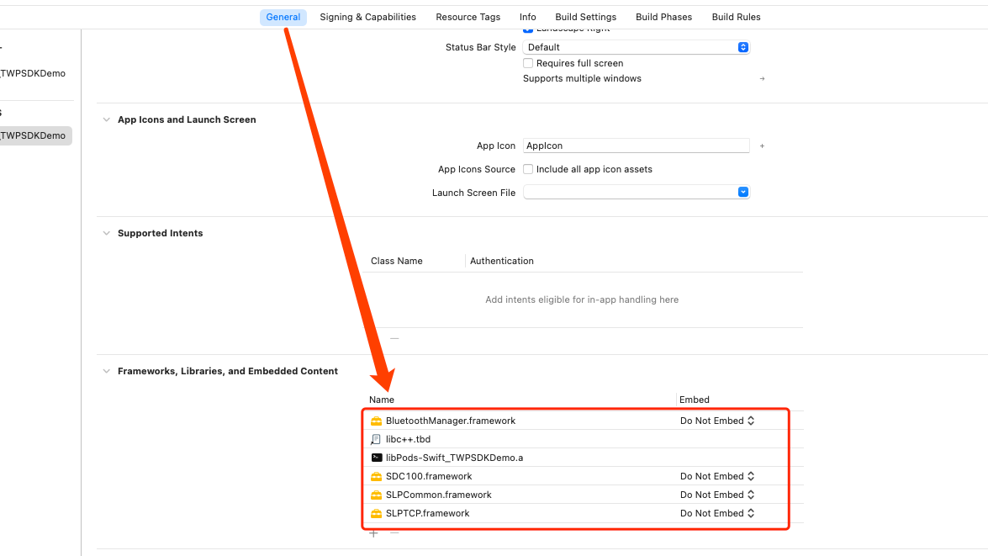
3: Setting other linker flags
-force_load $(SRCROOT)/RestonSDKDemo/BluetoothManager.framework/BluetoothManager
-force_load $(SRCROOT)/RestonSDKDemo/SDC100.framework/SDC100
Notice: the address after $(SRCROOT) is the Relative address of framework
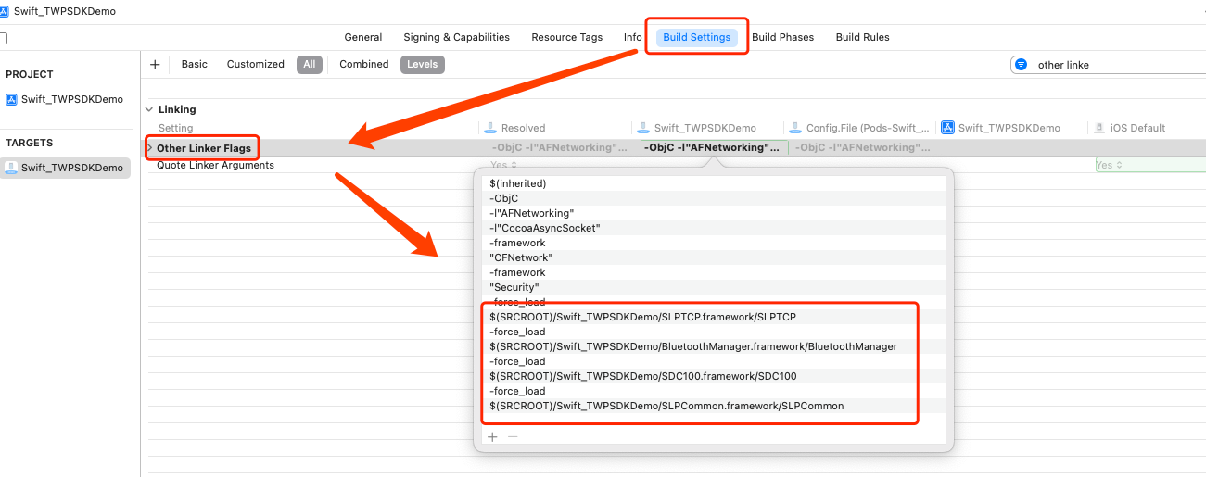

API

How to call method
#import <SDC100/SDC100.h>

[SLPBLESharedManager <method>]

eg: get the working status
[SLPBLESharedManager bleSDC100:(CBPeripheral *)peripheral getDeviceInfoTimeout:^(SLPDataTransferStatus status, id data) {
// do something
}];

1. Scan Bluetooth
- (BOOL)scanBluetoothWithTimeoutInterval:(CGFloat)timeOutInterval completion:(SLPBLEScanHandle)handle;

Description
Scan device

Parameters
SLPBLEScanHandle:
Field | Type | Description
code | SLPBLEScanReturnCodes | Need to be judged code == SLPBLEScanReturnCode_Normal frist  typedef NS_ENUM(NSInteger,SLPBLEScanReturnCodes) {  // Normal  SLPBLEScanReturnCode_Normal,  // BlueTooth is disable  SLPBLEScanReturnCode_Disable,  // Overtime  SLPBLEScanReturnCode_TimeOut,  };
handleID | int | The ID of this operation, ID use to stop scan
peripheralInfo | SLPPeripheralInfo | If code=SLPBLEScanReturnCode_Normal，response SLPPeripheralInfo

Stop Scan
- (void)stopScanHandle:(NSInteger)handleID;

Description
Stop scan

Parameters
Parameter | Type | Description
handleID | int | Get the handleID from “Scan Bluetooth” menthod

Connnect Device
- (void)bleSDC100:(CBPeripheral *)peripheral loginCallback:(SLPTransforCallback)handle;

Description
Connect SDC100 Ble

Parameters
Parameter | Type | Description
peripheral | CBPeripheral | sdc100
handle | SLPTransforCallback | if success, return data = SDCDeviceInfo

Get device info
- (void)bleSDC100:(CBPeripheral *)peripheral getDeviceInfoTimeout:(CGFloat)timeout callback:(SLPTransforCallback)handle;

Description
Get device info

Parameters
Parameter | Type | Description
peripheral | CBPeripheral | sdc100
timeout | int | Timeout, Unit(second)
handle | SLPTransforCallback | if success, return data = SDCDeviceInfo

SDC100 control function
-(void)bleSDC100:(CBPeripheral *)peripheral control:(NSDictionary *)params timeout:(CGFloat)timeout completion:(SLPTransforCallback)handle

Description
sdc100 control and work mode

Parameters
Parameter | Type | Description
peripheral | CBPeripheral | sdc100
params | NSDictionary | control params {@"keycode"=@"",@"ctrlVal"=@"",@"place"=@""}  *keycode {number}  0：stop  1: Falling (send once each at the start and end when a long press is detected)  2: rising  3: Movie viewing mode  4: Reading mode  5: Anti-snoring mode  6:0 gravity mode  7: FLAT mode  8: M1 custom mode Adjust to M1, save if the current state is not defined  9: M2 custom mode  10: Child lock  * ctrlVal {number} When the control parameter control code is 1/2/8/9, 0-short press 1-long press, when the control code is 10, 0-close the child lock 1-open the child lock, other control codes, the Field is invalid  * place {number} control position when the control code is 1/2 0: Back 1: Legs 2: Head 3: Waist
timeout | int | Timeout, Unit(second)
handle | SLPTransforCallback | if success, return

Under bed light switch
-(void)bleSDC100:(CBPeripheral *)peripheral lightCtrl:(int)on timeout:(CGFloat)timeout completion:(SLPTransforCallback)handle;

Description
Under bed light turn on or turn off

Parameters
Parameter | Type | Description
peripheral | CBPeripheral | sdc100
on | int | switch status :1 on , 0 off
timeout | int | Timeout, Unit(second)
handle | SLPTransforCallback | Callback

SDC100 params config init
-(void)bleSDC100:(CBPeripheral *)peripheral electricBedConfig:(NSDictionary *)params timeout:(CGFloat)timeout completion:(SLPTransforCallback)handle;

Description
sdc100 config params and init

Parameters
Parameter | Type | Description
peripheral | CBPeripheral | sdc100
params | NSDictionary | @{  * @place {number} control position 0: Back 1: Legs 2: Head 3: Waist  * @angle {number} angle  * @step {number} The number of steps the motor rotates  }
timeout | int | Timeout, Unit(second)
handle | SLPTransforCallback | Callback if succeed

Get SDC100 config info
-(void)bleSDC100:(CBPeripheral *)peripheral getElectricBedConfigTimeout:(CGFloat)timeout completion:(SLPTransforCallback)handle;

Description
Get sdc100 config info

Parameters
Parameter | Type | Description
peripheral | CBPeripheral | sdc100
timeout | int | Timeout, Unit(second)
handle | SLPTransforCallback | Callback,if succeed return data =SDCBedConfig

Get SDC100 work mode
-(void)bleSDC100:(CBPeripheral *)peripheral getWorkModeTimeout:(CGFloat)timeout completion:(SLPTransforCallback)handle;

Description
Get sdc100 work mode

Parameters
Parameter | Type | Description
peripheral | CBPeripheral | sdc100
timeout | int | Timeout, Unit(second)
handle | SLPTransforCallback | Callback,if succeed return data =SDCWorkMode

Snore meddle switch
-(void)bleSDC100:(CBPeripheral *)peripheral snoreMeddle:(NSDictionary *)params timeout:(CGFloat)timeout completion:(SLPTransforCallback)handle;

Description
snoring intervention to sdc100

Parameters
Parameter | Type | Description
peripheral | CBPeripheral | sdc100
params | NSDictionary | @{  * @enable {number} switch status 1 on , 0 off  * @side {number} 0 left, 1 right, 2 both sides  }
timeout | int | Timeout, Unit(second)
handle | SLPTransforCallback | if succeed, return

Get Snore meddle config
-(void)bleSDC100:(CBPeripheral *)peripheral getSnoreMeddleTimeout:(CGFloat)timeout completion:(SLPTransforCallback)handle;

Description
Get snore meddle config info

Parameters
Parameter | Type | Description
peripheral | CBPeripheral | sdc100
timeout | int | Timeout, Unit(second)
handle | SLPTransforCallback | Callback, if succeed return SDCSnoreMeddle

Subscribe snore status
-(void)bleSDC100:(CBPeripheral *)peripheral subSnoreStatus:(int)on timeout:(CGFloat)timeout completion:(SLPTransforCallback)handle;

Description
Subscribe snore status

Parameters
Parameter | Type | Description
peripheral | CBPeripheral | sdc100
on | int | 1 on ,0 off
timeout | int | Timeout, Unit(second)
handle | SLPTransforCallback | Callback

Get snoring status
-(void)bleSDC100:(CBPeripheral *)peripheral getSnoreStatusTimeout:(CGFloat)timeout completion:(SLPTransforCallback)handle;

Description
Get sdc100 snore status

Parameters
Parameter | Type | Description
peripheral | CBPeripheral | sdc100
timeout | int | Timeout, Unit(second)
handle | SLPTransforCallback | Callback, if succeed return SDCSnoreStatus

SDC100 clock
-(void)bleSDC100:(CBPeripheral *)peripheral clock:(NSDictionary *)params timeout:(CGFloat)timeout completion:(SLPTransforCallback)handle;

Description
Set sdc100 clock

Parameters
Parameter | Type | Description
peripheral | CBPeripheral | sdc100
timeout | int | Timeout, Unit(second)
params | NSDictionary | @{  @id {number} Alarm clock number, 0-4, supports up to 5 alarm clocks  @enable {number} Alarm clock switch, 0: off, 1: on  @smart {number} Whether smart is on, 0: off, 1: on  @offset {number} Smart start offset Valid when smart is turned on, unit: minute  @hour {number} hour, 24-hour clock (0-23)  @minute {number} minutes, 0-59  @repeat {number} Repeat 1-7, week 1-7 switch (digit 0-6) 0: off, 1: on  All 0s represent a single alarm,  @angle {number} Raise angle 0-60°  @side {number} wake-up position 0: left 1: right 2 left and right  @timestamp {number} Set timestamp. Standard timestamp when setting/modifying alarm clock (for single alarm clock)  @deleted {number} Is it valid? 0 means the alarm has been deleted. 1 The alarm is valid. Use this interface to delete the alarm and set this field to 0.  }
handle | SLPTransforCallback | Callback

Get SDC100 clock list
-(void)bleSDC100:(CBPeripheral *)peripheral getClockListTimeout:(CGFloat)timeout completion:(SLPTransforCallback)handle;

Description
Get sdc100 clock list

Parameters
Parameter | Type | Description
peripheral | CBPeripheral | sdc100
timeout | int | Timeout, Unit(second)
finishHandle | SLPTransforCallback | Callback,if succeed return clock array<*SDCClockInfo>

Clock global config
-(void)bleSDC100:(CBPeripheral *)peripheral globalClockConfig:(NSDictionary *)params timeout:(CGFloat)timeout completion:(SLPTransforCallback)handle;

Description
clock global config

Parameters
Parameter | Type | Description
peripheral | CBPeripheral | sdc100
params | NSDictionary | @{  @leftBed {number} is 1, the alarm is valid after leaving the bed, 0 is invalid  @side {number} 0 left, 1 right, 2 both sides  }
handle | SLPTransforCallback | if success return

Get SDC100 clock global config
-(void)bleSDC100:(CBPeripheral *)peripheral getGlobalClockConfigTimeout:(CGFloat)timeout completion:(SLPTransforCallback)handle;

Description
Get sdc100 clock global config

Parameters
Parameter | Type | Description
timeout | int | Timeout, Unit(second)
handle | SLPTransforCallback | if success, return data=SDCGlobalClock

18.SDC100 good night mode to set
-(void)bleSDC100:(CBPeripheral *)peripheral goodNightMode:(NSDictionary *)params timeout:(CGFloat)timeout completion:(SLPTransforCallback)handle;

Description
Set sdc100 good night mode

Parameters
Parameter | Type | Description
params | NSDictionary | @{  @enable {number} Good night mode switch 1 is enabled, 0 is not enabled  @flat {number} Sleep flat switch 1 is enabled, 0 is not enabled  }
timeout | int | Timeout, Unit(second)
handle | SLPTransforCallback | if success, return

19.Get SDC100 good night mode
-(void)bleSDC100:(CBPeripheral *)peripheral getGoodNightModeTimeout:(CGFloat)timeout completion:(SLPTransforCallback)handle;

Description
Get sdc100 good night mode

Parameters
Parameter | Type | Description
timeout | int | Timeout, Unit(second)
handle | SLPTransforCallback | if success, return data =SDCGoodNightMode

20.SDC100 leftbed mode to set

-(void)bleSDC100:(CBPeripheral *)peripheral leftBedMode:(NSDictionary *)params timeout:(CGFloat)timeout completion:(SLPTransforCallback)handle;

Description
Set sdc100 leftbed mode

Parameters
Parameter | Type | Description
params | NSDictionary | @{  @enable {number} 1 enables out-of-bed mode, 0 disables it  @flat {number} 1 is enabled when leaving the bed, 0 is disabled  @time {Number} Time out of bed  }
timeout | int | Timeout, Unit(second)
handle | SLPTransforCallback | if success, return

21.Get SDC100 leftbed mode

-(void)bleSDC100:(CBPeripheral *)peripheral getLeftBedModeTimeout:(CGFloat)timeout completion:(SLPTransforCallback)handle;

Description
Get sdc100 left bed mode

Parameters
Parameter | Type | Description
timeout | int | Timeout, Unit(second)
handle | SLPTransforCallback | if success, return data = SDCLeftbedMode

22.SDC100 leftbed night light to set
-(void)bleSDC100:(CBPeripheral *)peripheral nightLight:(NSDictionary *)params timeout:(CGFloat)timeout completion:(SLPTransforCallback)handle;

Description
Set sdc100 leftbed night light

Parameters
Parameter | Type | Description
params | NSDictionary | @{  @enable {number} Night light switch when leaving bed, 1 on, 0 off  @lamp {number} bedside lamp on switch, 1 on, 0 off  @startHour {number} starting hour, (temporarily invalid=0)  @startMin {number} starting minute, (temporarily invalid=0)  @endHour {number} End hour, (temporarily invalid=0)  @endMin {number} End minute, (temporarily invalid=0)  }
timeout | int | Timeout, Unit(second)
handle | SLPTransforCallback | if success, return

23.Get SDC100 leftbed night light

-(void)bleSDC100:(CBPeripheral *)peripheral getNightLightTimeout:(CGFloat)timeout completion:(SLPTransforCallback)handle;

Description
Get sdc100 leftbed night light

Parameters
Parameter | Type | Description
timeout | int | Timeout, Unit(second)
handle | SLPTransforCallback | if success, return data = SDCNightLight

24.SDC100 Snoring meddle to test

-(void)bleSDC100:(CBPeripheral *)peripheral snoringMeddleDemo:(int)on timeout:(CGFloat)timeout completion:(SLPTransforCallback)handle;

Description
Test sdc100 snoring meddle

Parameters
Parameter | Type | Description
on | int | on {number} 1 start, 0 end
timeout | int | Timeout, Unit(second)
handle | SLPTransforCallback | if success, return

Object definition

SLPTransforCallback

Description
Callback of all monthods

Method
typedef void(^SLPTransforCallback)(SLPDataTransferStatus status,id data);

Parameters
Filed | Type | Description
status | SLPDataTransferStatus | SLPDataTransferStatus
data | id | If status = SLPDataTransferReturnStatus_Succeed, data is available. See the method reference you will know how to change the data to the object you need.

SLPDataTransferStatus
Filed | Value | Description
SLPDataTransferStatus_Succeed | 0 | Success
SLPDataTransferStatus_ConnectionDisconnected | 1 | disconnected
SLPDataTransferStatus_TimeOut | 2 | Timeout
SLPDataTransferStatus_Failed | 3 | Failed
SLPDataTransferStatus_ConnectionDisabled | 4 | Bluetooth disabled
SLPDataTransferStatus_ParameterError | 5 | Parameter error

SLPPeripheralInfo

Description
The result of scanning bluetooth

Fields
字段 | Type | Description
peripheral | CBPeripheral | Bluetooth reference
name | String | deviceName

SDCDeviceInfo

Descrption
sdc100 device info

Fields
字段 | Type | Description
deviceID | NSstring | device id
deviceType | int | device type
currentHardwareVersion | NSstring | current hardware version
initialHardwareVersion | NSstring | init hardware version

SDCBedConfig

Description
sdc100 config info

Fields
Field | Type | Description
place | int | Control position 0: Right 1: Upper 2: Head 3: Waist
angle | int | angle
step | int | The number of steps the motor rotates

SDCWorkMode

Description
sdc100 work mode

Fields
Field | Type | Description
mode | int | work mode  0: Unknown status  1: Reserved  2: Reserved  3: Movie viewing mode  4: Reading mode  5: Anti-snoring mode  6:0 gravity mode  7: FLAT mode  8: M1 custom mode  9: M2 custom mode
adjusting | int | Push rod operating status 0: Stopped 1: Running
lock | int | Child lock status 0: closed 1: open
light | int | Under bed light status 0: off 1: on
angleBack | int | Back angle 0-90°
angleLeg | int | Leg angle 0-90°
angleHead | int | Head angle 0-90°
angleWaist | int | Waist angle 0-90°

SDCSnoreMeddle

Description
sdc100 snore meddle

Fields
Parameter | Type | Description
enable | Int | switch 1 on , 0 off
side | Int | 0 left, 1 right, 2 both sides

SDCSnoreStatus

Description
sdc100 snore status

Fields
Field | Type | Description
currentStatus | int | 0: No snoring 1 Snoring on the left side 2 Snoring on the right side 3 Snoring on both sides
left | int | Left side amplitude
right | int | Left side amplitude

SDCClockInfo

Description
sdc100 clock info

Fields
Field | Type | Description
id | int | 0-4 supports up to 5 alarm clocks
enable | int | Alarm clock switch 0: off, 1: on
smart | int | Whether to turn on smartly 0: off, 1: on
offset | int | Smart start offset Unit: minutes Valid when smart is turned on
hour | int | 24-hour clock hour (0-23)
minute | int | Minutes (0-59)
repeat | int | repeat mode，For example: 00000111, from right to left, represents Monday, Tuesday, Wednesday respectively, if the bit is 1, that means it will repeat at the same day, otherwise, it will not repeat. 127(decimalism) = 1111111(Binary), it means repeating from Monday to Sunday. 16 = 0010000, it means just repeating on Friday
angle | int | Lift angle 0-60°
side | int | Wake-up position 0: Left 1: Right 2 Left and right
timestamp | int | Set timestamp Set/modify the standard timestamp when alarming (for single alarm)
deleted | int | Is it valid? 0 means that the alarm clock has been deleted. 1. The alarm clock is valid. To delete the alarm clock, use this interface and set this field to 0.

SDCGlobalClock

Description
sdc100 global clock config info

Fields
Field | Type | Description
leftBed | int | When it is 1, the alarm clock is valid after leaving the bed, and when it is 0, it is invalid.
side | int | 0 left, 1 right, 2 both sides

SDCGoodNightMode

Description
sdc100 good night mode

Fields
Field | Type | Description
enable | int | Good night mode switch 1 is enabled, 0 is not enabled
flat | int | Sleeping flat switch 1 is enabled, 0 is not enabled

SDCLeftbedMode

Description
sdc100 leftbed mode

Fields
Field | Type | Description
enable | int | Bed mode switch 1 enables, 0 disables
flat | int | 1 is enabled when lying flat on the bed, 0 is disabled
time | int | leftbed duration

SDCNightLight

Description
sdc100 leftbed night light

Fields
Field | Type | Description
enable | int | Night light switch when leaving bed 0: Disabled 1: Enabled
lamp | int | Under bed light switch 0: Disabled 1: Enabled
startHour | int | Start hour 0-23(invalid,0)
startMin | int | Start minutes 0-59(invalid,0)
endHour | int | end hour 0-23(invalid,0)
endMin | int | End minutes 0-59(invalid,0)

Notification

Description
push ble device notification

Fields
Notification name | description
kNotificationNameBLEDeviceDisconnect | Ble device disconnected，notification params: deviceName（the disconnected deviceName：SA1001***，Z400T****），deviceType
kNotificationNameBLEDeviceConnected | Ble device connected，notification params:  deviceName（the disconnected deviceName：SA1001***，Z400T****），deviceType
kNotificationNameBLEEnable | Ble device enable
kNotificationNameBLEDisable | Ble device disable

